1.Students details who enrolled for course Big Datat

select * from weekend_joining where course='Big Data';

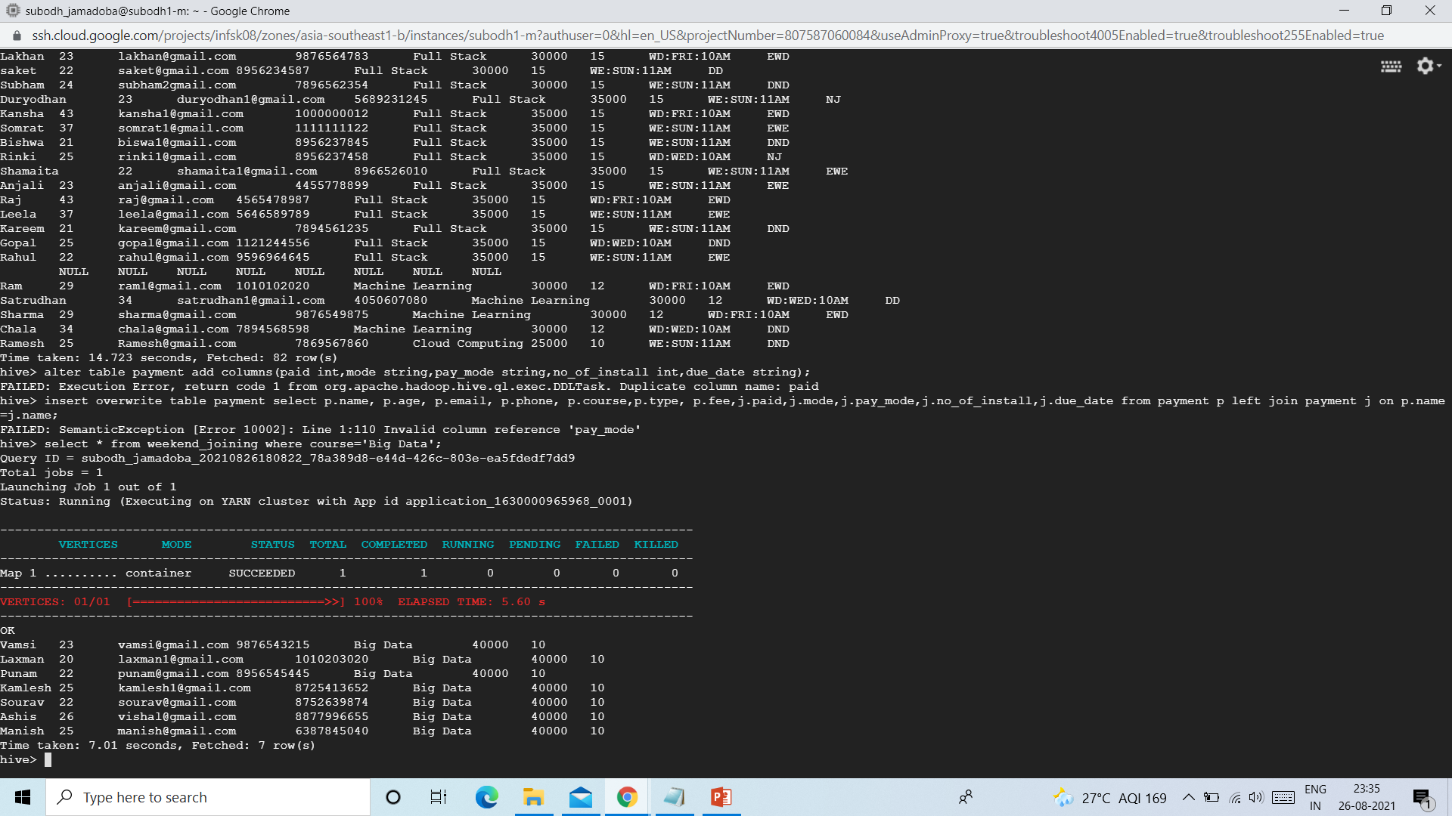

2.Students who are not done with the payments

select * from payment where due_date!='paid';

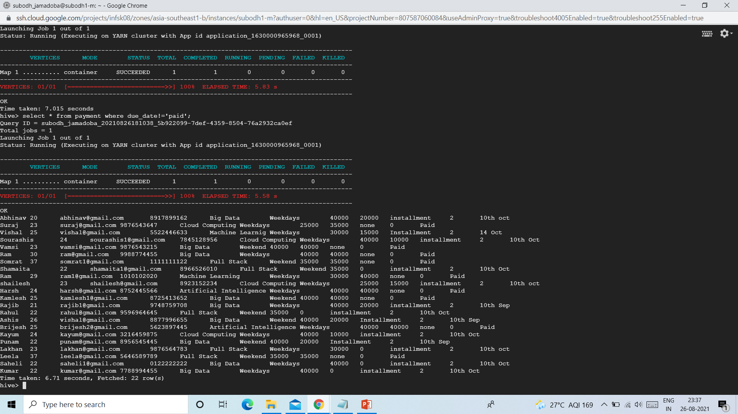

3.students who joined course cloud computing from weekend

select * from weekdays_joining where course='Cloud Computing';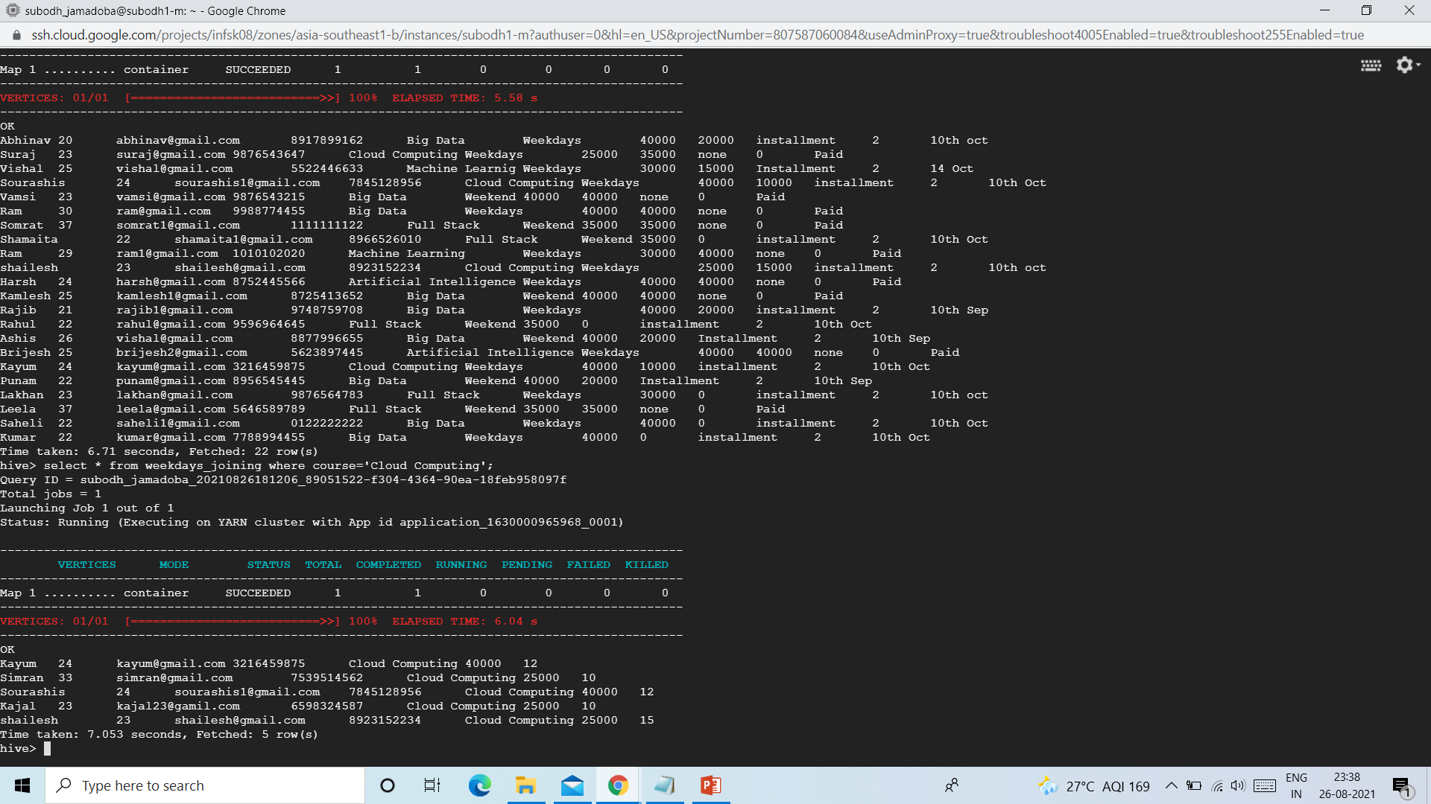

4.students with age more than 24

select * from enquiry where age > 24;

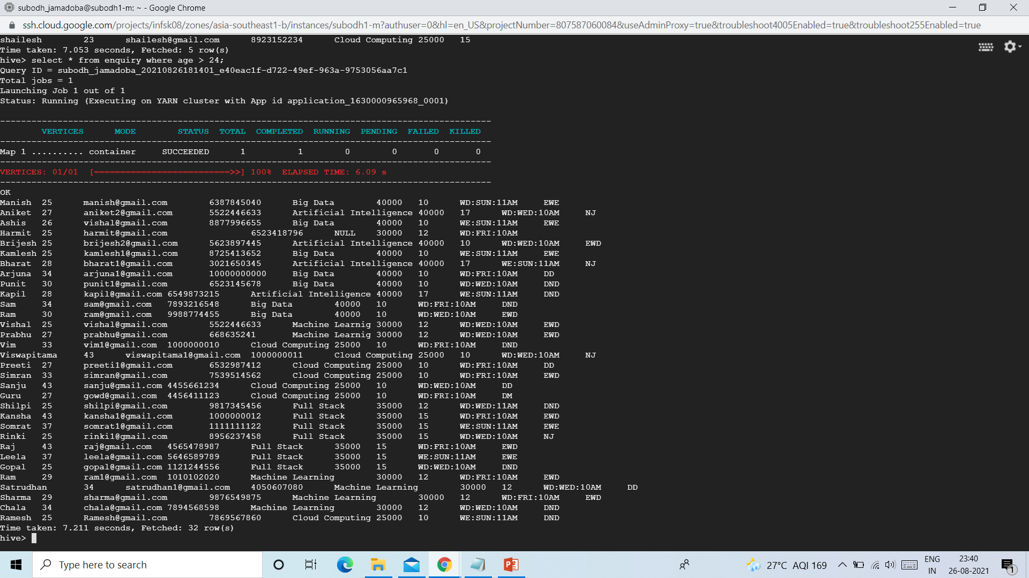

5.students who are more than 24 and from Big data course

select * from enquiry where age > 24 and course = 'Big Data';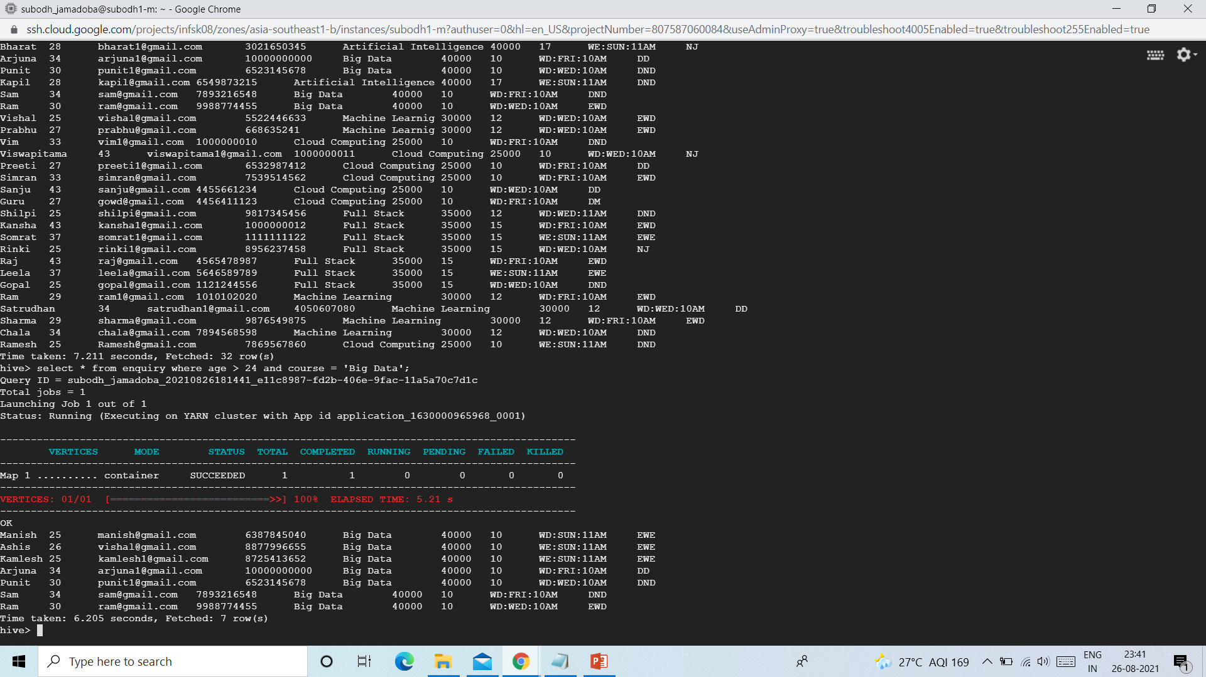

6.students who done the course payment with half of its course fee

select * from payment where paid >=(fee/2);

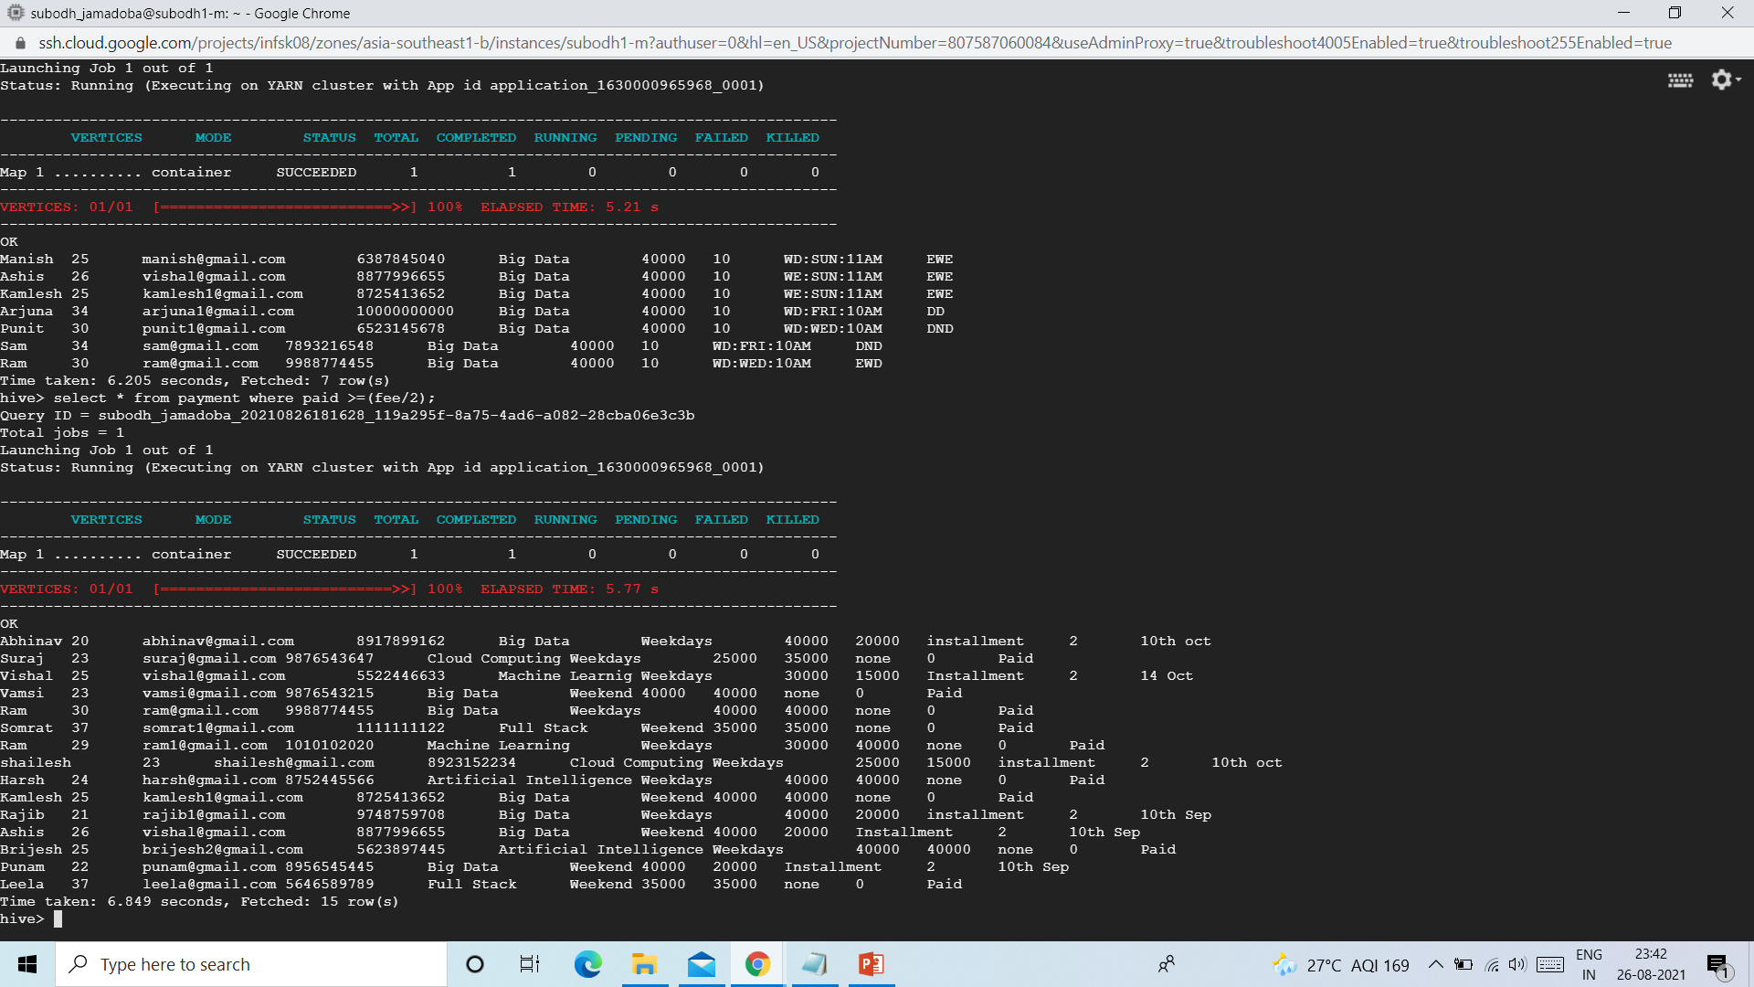

7.show all different courses available

select DISTINCT course from enquiry;

Artificial Intelligence

Big Data

Cloud Computing

Full Stack

Machine Learnig

Machine Learning

8.students who got more than 10 % discount and age more than 22

select * from enquiry where discount<=10 and age >22;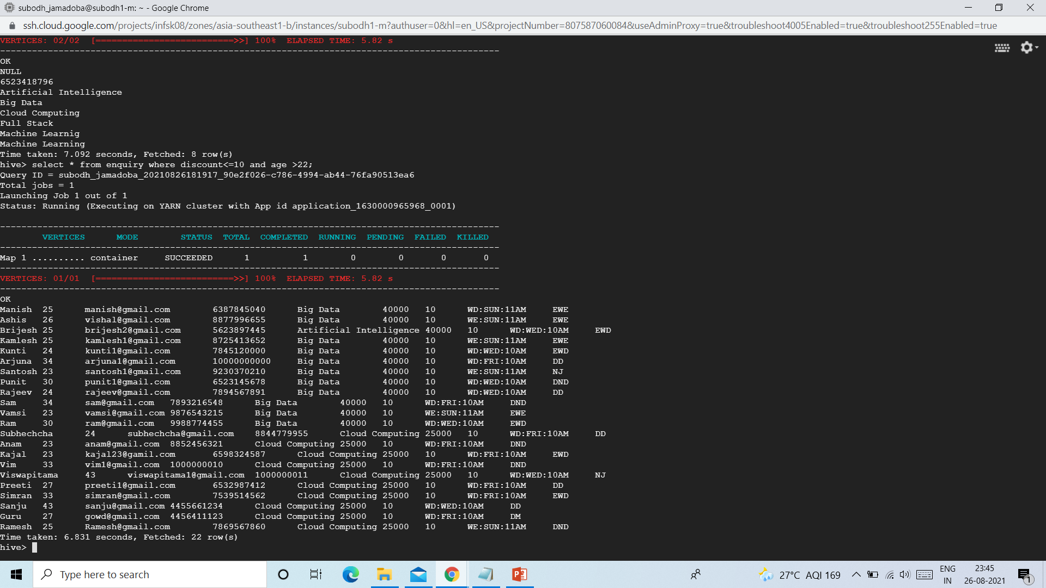

9.all the course and their fee from enquiry table

select course,fee from equiry;